### Java Fundamentals 7-3: The Static Modifier and Nested Classes Practice Activities

### Vocabulary Definitions

1. **Static Method**: Is a method that is available for use without first creating an instance of the class. It is declared by preceding its definition with the static modifier.
2. **Nested Class**: Is any class implemented as a nested class within another class. By definition, all inner classes are members of the container class by composition.
3. **Static Variable**: Any Java class-level variable that is declared with the static modifier. This means only one instance of the class variable can exist in the JVM regardless of the number of class instances.
4. **Static Keyword**: Is a keyword that makes a variable, method, or inner class available without first creating an instance of a variable.
5. **Inner Class**: Is an inner class. Inner classes are defined within a parent or container class and are members of the container class by composition. In fact, inner classes are the only way you can create class instances through composition.
6. **Static Inner Class**: Is an inner class that is available for use without first creating an instance of the container class. It is declared by preceding its definition with the static modifier.
7. **Class Method**: Any Java method defined with a static modifier. It is accessible outside the class when a public, protected, or default access specifier precedes it. It is private and inaccessible outside of the class when a private specifier precedes it. Class methods are available without first creating an instance of the class.
8. **Static Variable**: Is a variable that may be available outside of a class without first creating an instance of a class. It is declared by preceding the variable name with the static modifier.

### Tasks

#### Task 1: Creating the Vehicle Class

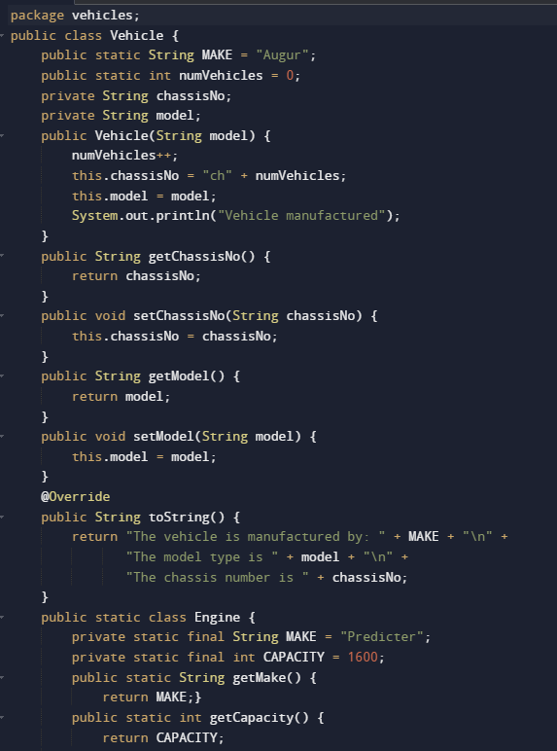

Task 2: Creating the TestVehicle Class

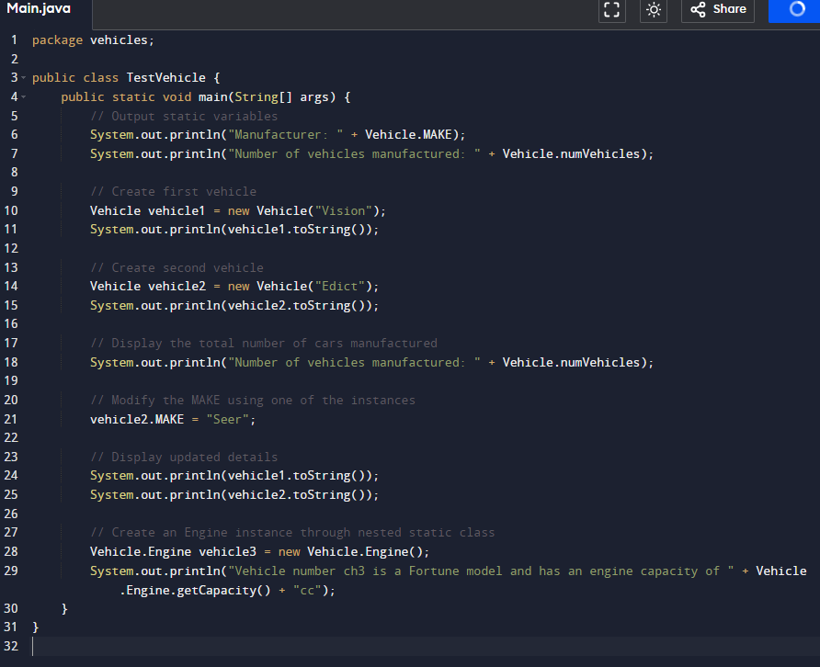

### Task Outputs

The expected outputs after running the provided Java classes are as follows:

#### Task 1 Output

